Spring Framework

It is known as framework of frameworks. We can create spring project either by maven or gradle. These are build tools

Inversion Of Control ?

Inversion of Control is a principle in software engineering which transfers the control of objects or portions of a program to a container or framework.

Ioc means give the control to framework itself you don’t have to control yourself. Youd don’t have to create every object you need bcz there will be 100s of classes and if you create and destroy yourself for garbage collection it will be difficult. We need to focus on business logic.

Dependency Injection ?

Dependency injection is a pattern we can use to implement IoC, where the control being inverted is setting an object's dependencies. Connecting objects with other objects, or “injecting” objects into other objects, is done by an assembler rather than by the objects themselves. If one class needs object of other class then spring will give that.

Lets take example:

Class Laptop{

Harddrive obj1;

Ram obj2;

}

So Laptop is dependent on object Harddrive so how will you use that inside this class is

Class Laptop{

HitachiHd obj1=new HitachiHd();

}

Now if in future you want use different harddrive samsung we need to create again. So here tight coupling is hapenning. But we need to achieve loose coupling i.e, one object should not be totally depend on other object it may be replaced. By Abstraction you can use that.. so we can use abstract classes or interface.

class Hardrive implements HitachiHd{}

class Laptop{

Harddrive obj1=new HitachiHd();

}

But still we are hardcoding here. When we use new, it is tight coupling. So someone needs to give us that object. So by DI harddrive object will be injected in laptop. So there will spring container and they are responsible to create object. We need to configure in by creating xml file. So if someone is asking this object give to them. So we can edit xml file in future if needed. This is not tight coupling.

By using spring boot we can use annotations like @Component

@Component

class Hardrive implements HitachiHd{}

This will treat as component by spring. This will be object by srping.

Class Laptop{

@Aurowired

Harddrive obj1;

}

By Autowiring spring will inject harddrive object into Laptop

Uses of DI

1 Loose coupling

2 Testing

In testing if loose coupling is achieved then we don’t want to test that dependent object. Suppose in java if one class is using database object. So we don’t want to test database object. So we can create mock of db object and w e can only test main class.

IOC Container Find Beans by @Component, wire dependencies by @Autowired, and manage lifecycle of bean.

We have two interfaces Bean Factory and Application Factory to get bean. These 2 are IOC containers.

ApplictaionFactory is super set to Bean Factory. These both are spring containers. The Spring IOC container will create the objects, wire them together, configure them, and manage their complete life cycle from creation till destruction. The Spring container uses DI to manage the components that make up an application. These objects are called Spring Beans

The container gets its instructions on what objects to instantiate, configure, and assemble by reading the configuration metadata provided. The configuration metadata can be represented either by XML, Java annotations, or Java code. The following diagram represents a high-level view of how Spring works.

In most Java enterprise applications, Application context rather than BeanFactory bcz it has more feature i.e it has all features of bean factory and also,Internationalization, AOP features, WebApplicationContext for web apps. Bean factory only has spring core features.



Setter Injection & Constructor Injection

We are just defining setter, getter and constructor and configuring those in spring.xml then spring will intialiaze those and give to us. If spring bean class is having more than one property then it is better to use setter injection because it reduces burden on the programmer. Setter injection reduces burden on the programmer because programmer need not to worry about index, type of parameters as in the case of constructor injection. It is not mandatory that all properties must be configured for injection. Properties can be left with their default values.



Annotation based configuration

**@Component** indicates that this class should be create as bean. **@ComponentScan** is searching packages for Components.

Java based configuration

Spring @Configuration annotation is part of the spring core framework. Spring Configuration annotation **indicates that the class has @Bean definition methods**. So Spring container can process the class and generate Spring Beans to be used in the application.

Rather than using spring.xml w ecan use like below by java configuration



Scopes

There are different types of Scopes. Important are Singleton (default) and Prototype.

This **Singleton scope** is the default bean definition to have a single instance per Spring IoC container. This scopes a single bean definition to have any number of object instances. This scopes a bean definition to an HTTP request.

If you observe below eventhough we are getting same second object from spring container as it follows singleton pattern



Prototype

If you define @Scope(“scopeName=prototype”) on top of the Car class. Then ,your second object will be different.

There are four additional scopes that are only available in a web-aware application context. We use these less often in practice.

The *request* scope creates a bean instance for a single HTTP request, while the s*ession* scope creates a bean instance for an HTTP Session.

The *application*scope creates the bean instance for the lifecycle of a *ServletContext*, and the *websocket*scope creates it for a particular *WebSocket*session.

Are spring beans thread safe?

No, bcz if there are multiple threads executing by defualt spring scope is singleton so all threads share same bean. So its not thread safe.

Lifecycle of a bean

Bean life cycle is managed by the spring container. When we run the program then, first of all, the spring container gets started. After that, the container creates the instance of a bean as per the request, and then dependencies are injected. And finally, the bean is destroyed when the spring container is closed. Therefore, if we want to execute some code on the bean instantiation and just after closing the spring container, then we can write that code inside the custom **init()** method and the **destroy()** method.

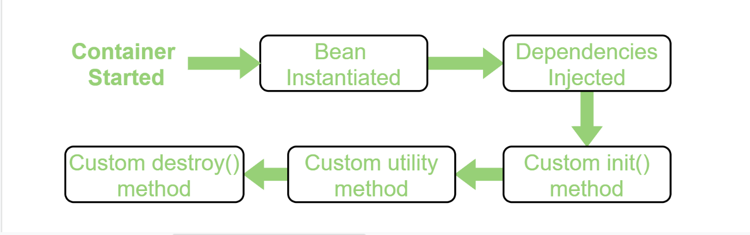

**Using Annotation:** To provide the facility to the created bean to invoke custom **init()** method on the startup of a spring container and to invoke the custom **destroy()** method on closing the container, we need annotate **init()** method by **@PostConstruct** annotation and **destroy()** method by **@PreDestroy** annotation.  
**Note:** To invoke the **destroy()** method we have to call the **close()** method of ConfigurableApplicationContext.

**public** **class** HelloWorld {

    // Annotate this method to execute it

    // automatically as the bean is

    // instantiated

    @PostConstruct

**public** **void** init() **throws** Exception {

     System.out.println("Bean HelloWorld has been instantiated and I'm the init() method"); }

    // Annotate this method to execute it

    // when Spring container is closed

    @PreDestroy

**public** **void** destroy() **throws** Exception{

        System.out.println("Container has been closed and I'm the destroy() method");}

}

Spring.xml

<**beans**>

    <!-- activate the @PostConstruct and

@PreDestroy annotation -->

    <**bean** class="org.springframework

.context.annotation

.CommonAnnotationBeanPostProcessor"/>

    <!-- configure the bean -->

    <**bean** class="beans.HelloWorld"/>

</**beans**>

// Driver class

**public** **class** Client {

**public** **static** **void** main(String[] args)

**throws** Exception

    {

        // Loading the Spring XML configuration

        // file into Spring container and

        // it will create the instance of the

        // bean as it loads into container

        ConfigurableApplicationContext cap

            = **new** ClassPathXmlApplicationContext(

                "resources/spring.xml");

        // It will close the Spring container

        // and as a result invokes the

        // destroy() method

        cap.close();

    }

}

Spring AspectOrientedProgramming (AOP)

When we work with Java application. In a class in a method there will be log staements before and after business logic, authentication & authorization, Database transaction should be started and ended and our business logic. We need to fouc maninly on our business logic itself rather than others. There may be many methods. By AOP you can separate all those in other class without even calling that method in caller method. So that separate class is called as Aspect and annotated with Aspect. So all the above discussed cross cutting concerns we can eliminate by keeping all those in this separate class. We need to define aspect dependencies in our pom.xml. AOP supports OOP.

Example //can also refer Aop project in java projects

class Shoppingcart{

Void orderItem(){

Log lines

authentication & authorization

Database transaction begin

Our business logic

Log lines

}}

Advise means what to execute or what you want to do.There are different types of aspects.

Types of Advises: Before,After,AfterReturning,AfterThrowing,After finally,Around

like before the method ( @Before )or after the method(@After)

Pointcut means where to execute at which method? Or expression present inside the advise annotation i.e for which methods in which package

PointCut is a set of one or more JoinPoints where an advice should be executed. You can specify PointCuts using expressions or within patterns In Spring, PointCut helps to use specific JoinPoints to apply the advice. Consider the following examples −

* expression = "execution(* com.tutorialspoint.*.*(..))"
* expression = "execution(* com.tutorialspoint.Student.getName(..))"

For every method executed in actual class there will be **joinpoint**. Joinpoint is specific execution point of Aspect.

JoinPoint It is the actual place in the application where an action will be taken using Spring AOP framework. Consider the following examples −

* All methods classes contained in a package(s).
* A particular methods of a class.

We need to Enable Aop in helper class by this @EnableAspectJAutoProxy

**Also refer aop project in javaprojects folder to get better understanding on pointcut & joincut**

@Component

class ShoopingCart{

void orderItem(){

//business logic

}

}

@Component

@Aspect

@EnableAspectJAutoProxy

Class Helper{

*// @Before("execution(public void drive())")*@Before("execution(* org.example.Vehicle.drive())")*//* means any return type* public void logBefore(){  
 System.*out*.println("before method");  
 }  
  
 @After("execution(* *.*.drive())")*// any return type any package any class in this method* public void logAfter(){  
 System.*out*.println("after method");  
 }

}

Servlet & JSP

Servlet is a Java programming lang class used to extend the capabilities of servers that host applications access by means of a request-response programming model

Means Servlet will take request from th web server and gives response back

When a user types url in browser then it sends to web server and sends to web container which has many servlets. So Web.xml determines which servlet to routes based on the input url. Then servlet takes input as http request and process it and produces output as Http response. Servlet class extends HttpServlet which has many methods like doGet(), doPost…. Etc.



In Web.xml there will be two tags servlet determines class & servlet-mapping which determines url to map

<sevlet>

<servlet-name>login</servlet-name>

<servlet-class>com.in28minutes.LoginServlet</servlet-class>

<servlet>

<servlet-mapping>

<servlet-name>login</servlet-name>

<url-pattern>/login</url-pattern>

</servlet-mapping>

Servlet Example without JSP

//1. extends javax.servlet.http.HttpServlet

//2. @WebServlet(urlPatterns = "/login.do")

//3. doGet(HttpServletRequest request, HttpServletResponse response)

//4. How is the response created?

@WebServlet(urlPatterns = "/login.do")

public class LoginServlet extends HttpServlet {

@Override

protected void doGet(HttpServletRequest request, HttpServletResponse response) throws IOException {

PrintWriter out = response.getWriter();

out.println("<html>");

out.println("<head>");

out.println("<title>Yahoo!!!!!!!!</title>");

out.println("</head>");

out.println("<body>");

out.println("My First Servlet");

out.println("</body>");

out.println("</html>");

}}

Here in above code, it is the servlet which takes request and process response but if you observe we are writing HTML code in static way by java code which becomes difficult. So to make it easier JSP comes which writes dynamically by HTML code. Eventhough at last JSP also converts into servlet.To riderect request from servlet to jsp we need to use requestdispatcher as shown in below code.

We will be having request params which can be sent from url. In that if you send password then there will be n routers in browser any one can see that through so better to use doPost().

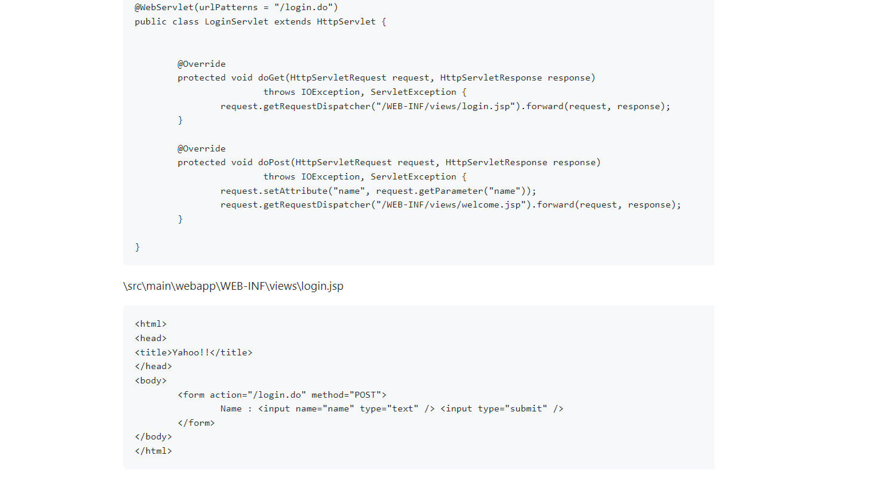

What is Apache Tomcat ?

Apache Tomcat is a popular source web server & servlet container for java code.

So if someone wants to send http requests then they needs Http Server. So we need Http Server and we need container where we will run or servlet, so when we combine Http server and the servlet(say Servlet container) they both combine to become a single server known as tomcat server. So simply Apache tomcat is a server and servlet container.

Why we need Servlet Filter ?

Servlet Filter is an interface similar to Http servlet and has methods like doFilter().

When request is sent by user we can validate in servlet also but when we have lot of servlets and jsps, it will become difficult. Or something is changes in future all places we need to change. So we need to use servlet filter which is pluggable java component. Servlet filter gets intercepted before going to servlet itself.

It is used for validation, authentication etc

Http Session means it will store some information and recognizes when same user is logged in again. Cookie is small information which servlet (it is like token) sends to the server for session management. By this token it identifies whether unique or not.

Spring MVC

In Servlets every servlet behaves as controller and every JSP behaves as view

So here in Spring MVC there will be lot many controllers but how to route to particular controller. So there will be front controller known as Dispatcher Servlet which is provided by spring. So when request is received from client. In web.xml we configures to use dispatcher servlet. But how dispatcher servlet will know which controller to route so we use @Controller tag on controller classes and there will be some mapping. The main advantage is we don’t need to configure for which particular url which particular class. Here, we will be having separate class for the dispatcher servlet to route, we just configure the base package of the controller classes. This class name should be servlet name-servlet.xml. servlet name we will configure in web.xml. ex: telusko-servlet.xml

So In controller processing will happen and it will return name of the page. There will be lots of jsp pages. So controller returns which page to forward. Controller will return data(model) and view of the page to the dispatcher servlet. So by that view name dispatcher servlet gets the view from jsp class. Then the response will be sent to the client form dispatcher servlet. But why dispatcher servlet needs to call the view. For the view there will be different technologies like JSP,thymeleaf, Velocity. If anyone changes in future. Then just by changing configuration file. It will be ok. So controllers will not know which type of views will be used so this **Advantage seperation of concern.** That means your view will not concern on controllers also. **Unit Testing also becomes easy as of seperation of concern.**

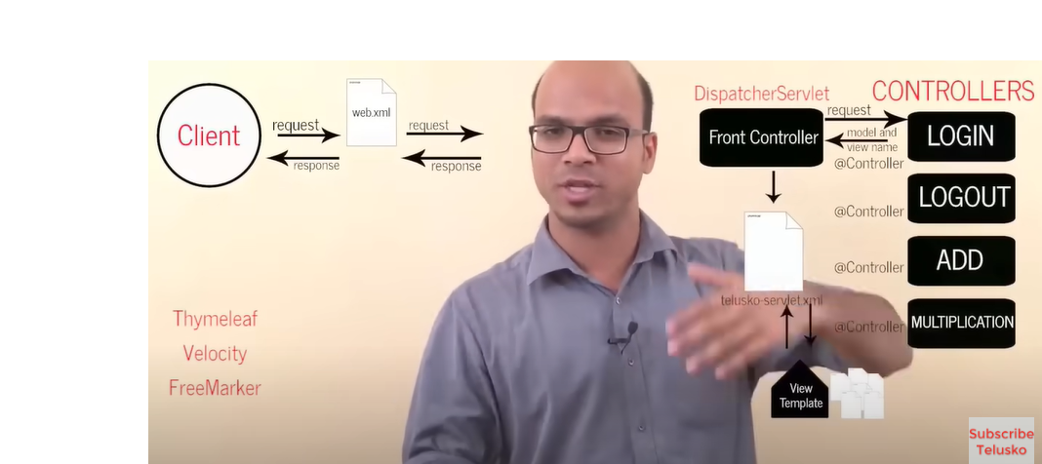

In normal MVC, we will be having model, view and controller. So when we send request from the server. Request is received by controller and process happen. Then controller ask data from database in the form of model and that data will be displayed on page that page is view. In Spring MVC In big projects there will multiple controllers. So there will be main controller it routes to which controller to route. Below example is spring mvc example with java config. So web.xml is replaced by MyWebinitializer class and Telusko-servlet.xml(dispatcher servlet config) is replaced by telusko config class We can also use xml config.

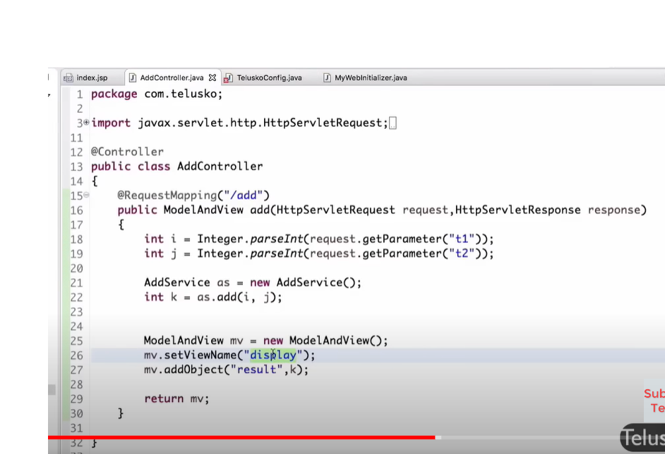

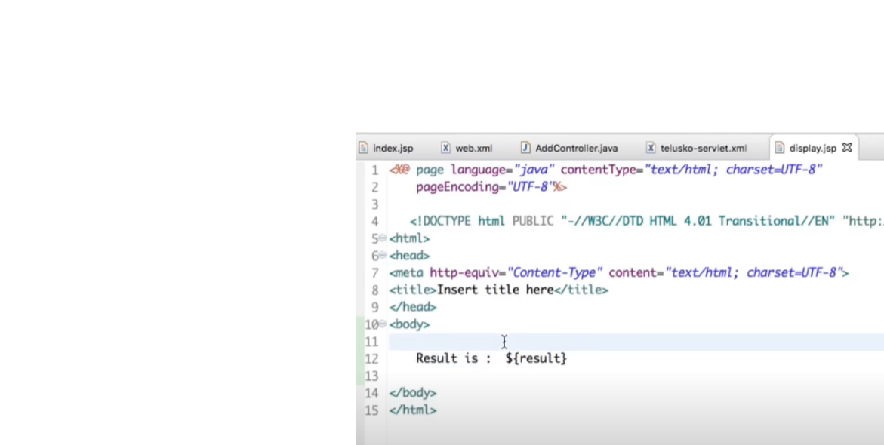

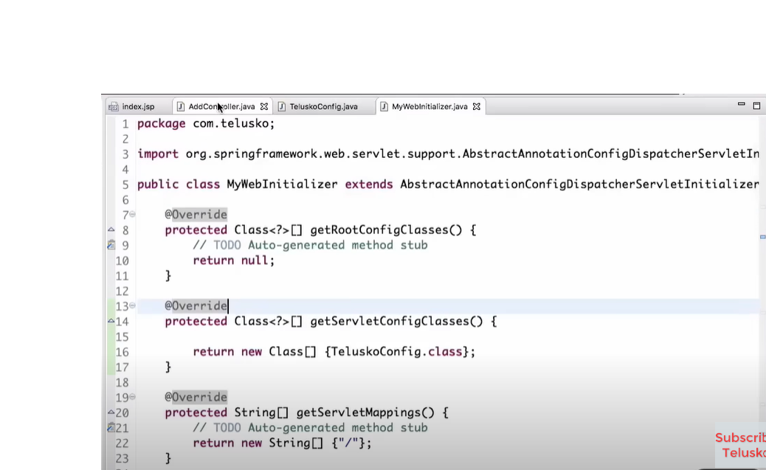

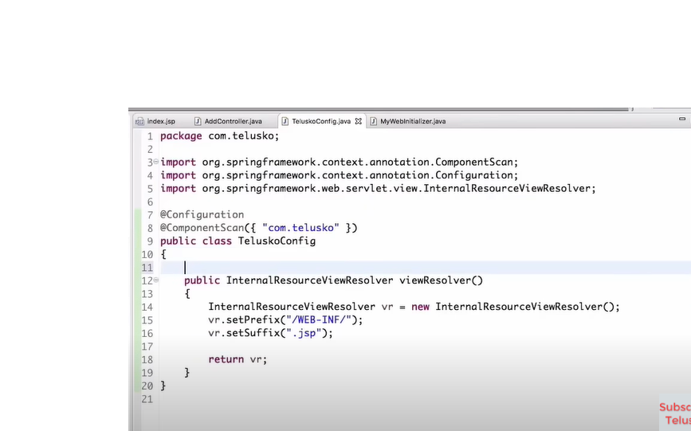

JDBC without spring

To get data we need to connect database. So here we use jdbc. By Jdbc below image we can see that for getting simple circle object we need to write lot of boiler plate code like mentioning driver, opening connections and closing connections. We need to handle excpetions.

If we don’t handle exception then there will be big problem.

Psvm{

Circle circle=new JdbcDaoImpl().getCircle(1);

Syso(circle.getName());

}

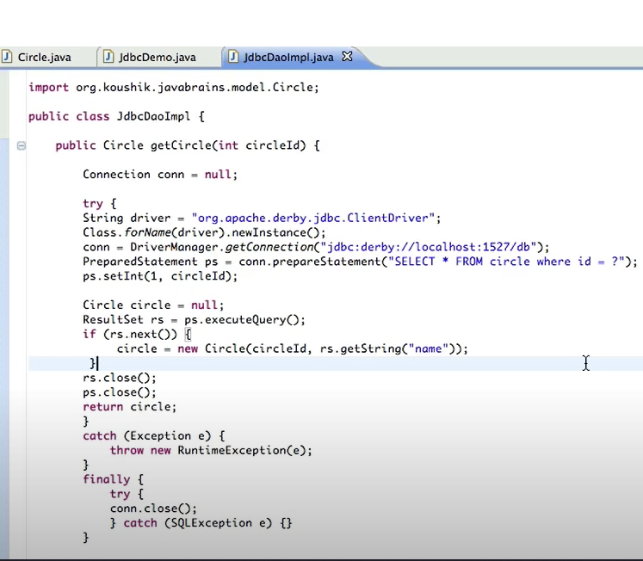

Spring JDBC

Spring **JdbcTemplate** is a powerful mechanism to connect to the database and execute SQL queries. It internally uses JDBC api, but eliminates a lot of problems of JDBC API.

Problems of JDBC API

The problems of JDBC API are as follows:

* We need to write a lot of code before and after executing the query, such as creating connection, statement, closing resultset, connection etc.
* We need to perform exception handling code on the database logic.
* We need to handle transaction.
* Repetition of all these codes from one to another database logic is a time consuming task.

Advantage of Spring JdbcTemplate

Spring JdbcTemplate eliminates all the above mentioned problems of JDBC API. It provides you methods to write the queries directly, so it saves a lot of work and time.

Above mentioned code in jdbc without spring jdbc is modified with spring jdbc in below images. Jdbc uses jdbc template but it doesn’t support for named query paramaters. So we can use Simplejdctemplate. Here in spring jdbc we have rowmapper which maps specific fields to the fields in rows of the database object. By using ORM Hibernate framework it directly maps.











**Hibernate(ORM Framework)**

Java works on objects while databases works on table. How to map these objects with the tables.

In Java object lets say Employee and fields firstName will be first_name in datab ase how to map that firstName to this first_name.In Jdbc, we will be getting data from database and converting into objects and setting those fields. But we don’t need to do that by hibernate while creating Employee class we keep @Entity and @Column Name that maps objects to the database table and its fields. This is ORM. So we have ORM Frameworks. ORM means Object Relationship Mapping.

Hibernate is an Object-Relational Mapping (ORM) tool that is used to save the Java objects in the relational database system.

**Spring JPA(Java Persistence API)**

JPA is java programming application interface specification that describes the management of relational data in application using java platform.

JPA helps us to eliminate writing queries to select, update etc by using find,update we can achieve without queries and jdbc stuff….

Java uses ORM tools like hibernate or Ibatis or Toplink to map objects to tables in db. But say if you want to switch from hibernate to Toplink in future it will be difficult as your code is written in hibernate as all tools have different structure and different specification. So Sun microsystem, came with JPA which is just specification and implementation will be hibernate or any other orm tool. So you can shift easily.

|  |  |
| --- | --- |
| JPA | HIBERNATE |
| It describes the handling of relational data in Java applications. | Hibernate is an Object-Relational Mapping (ORM) tool that is used to save the Java objects in the relational database system. |
| It is not an implementation. It is only a Java specification. | Hibernate is an implementation of JPA. Hence, the common standard which is given by JPA is followed by Hibernate. |
| It is a standard API that permits to perform database operations. | It is used in mapping Java data types with SQL data types and database tables. |

***Conclusion:****The major difference between Hibernate and JPA is that Hibernate is a framework while JPA is API specifications. Hibernate is the implementation of all the JPA guidelines.*

EntityManager

In Java entities will be there that are tables in db. To manage these entites we have Entity Manager. An object referenced by an entity is managed by entity manager. Entity manager is used to read, delete and write an entity.

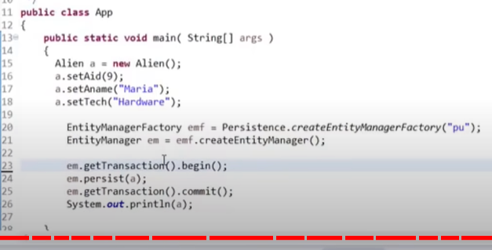

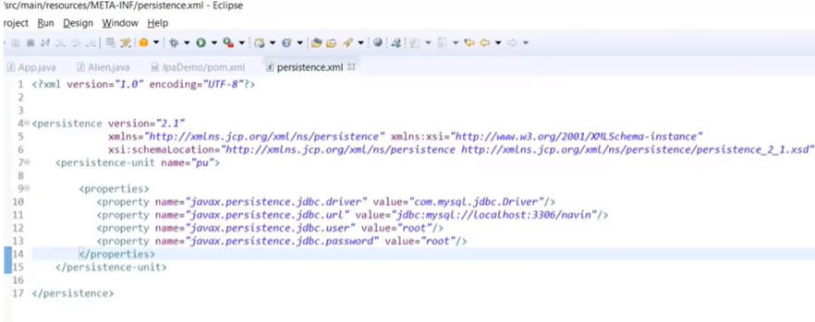

Steps to persist an entity object.

1) Creating an entity manager factory object

The **EntityManagerFactory** interface present in **java.persistence** package is used to provide an entity manager.

1. EntityManagerFactory emf=Persistence.createEntityManagerFactory("Student_details");

* **Persistence -** The Persistence is a bootstrap class which is used to obtain an EntityManagerFactory interface.
* **createEntityManagerFactory() method -** The role of this method is to create and return an EntityManagerFactory for the named persistence unit. Thus, this method contains the name of persistence unit passed in the Persistence.xml file.

2) Obtaining an entity manager from factory.

1. EntityManager em=emf.createEntityManager();

* **EntityManager -** An EntityManager is an interface
* **createEntityManager() method -** It creates new application-managed EntityManager

3) Intializing an entity manager.

1. em.getTransaction().begin();

* **getTransaction() method -** This method returns the resource-level EntityTransaction object.
* **begin() method -** This method is used to start the transaction.

4) Persisting a data into relational database.

1. em.persist(s1);  //similar to this we can update, delete, find also

* **persist() -** This method is used to make an instance managed and persistent. An entity instance is passed within this method.

5) Closing the transaction

1. em.getTransaction().commit();

6) Releasing the factory resources.

1. emf.close();
2. em.close();

* **close() -** This method is used to releasing the factory resources.

**If we need two objects(entities) in different classes but they need to store in single table then we need to use @Embedded annotation**

**JPA provides the @Embeddable annotation to declare that a class will be embedded by other entities. @Embedded is used to embed a type into another entity.**

**@AttributeOverrides**

Our fields were called things like *contactFirstName* in our original *Company* class and now *firstName* in our *ContactPerson*class. So, JPA will want to map these to *contact_first_name*and *first_name*, respectively.

Aside from being less than ideal, it will actually break us with our now-duplicated *phone* column.

**So, we can use *@AttributeOverrides* and *@AttributeOverride* to override the column properties of our embedded type.**

@Embeddable

@AttributeOverrides({

@AttributeOverride( name = "firstName", column = @Column(name = "contact_first_name")),

@AttributeOverride( name = "lastName", column = @Column(name = "contact_last_name")),

@AttributeOverride( name = "phone", column = @Column(name = "contact_phone")) })

public class ContactPerson {

private String firstName;

private String lastName;

private String phone;

// standard getters, setters

}

@Entity

public class Company {

@Id @GeneratedValue

private Integer id;

private String name;

@Embedded

private ContactPerson contactPerson;

// standard getters, setters }

There are many methods provided JPA like below

findAll

findByStudentName(String StudentName)

findByFirstNameContaining(“kash”)

findByFirstNameAndLastName(String f,String l)

findByAgeLessThan()

Some cases these methods are not enough so we can write JPQL queries by @Query

In JPQL,  Instead of the database table, JPQL uses entity object model to operate the SQL queries. Here, the role of JPA is to transform JPQL into SQL

Means when writing queries we need to mention fields names in entity rather than column names in sql i.e like firstName but not first_name

Advantages

* It is simple and robust.
* It is a platform-independent query language.

Examples

//JPQL

@Query(“Select s from Student s where s.emailId=?1”)

Student getStudentByEmailId(String emailId);

Now if complex scenarios occurs Jpa allows to write queries by Native Sql queries

//Native Query here we can mention db table names

@Query(value=“Select * from student s where s.email_id=?1”, nativeQuery=true)

Student getStudentByEmailId(String emailId);

//Named Query (Easy to read(Redable) when multiple parameters are passed as input)

@Query(value=“Select * from student s where s.first_name=:firstName and s.last_name:lastName”, nativeQuery=true)

Student getStudentByFirstNameAndLastName (String firstName, String lastName);

@Modifying

@Transactional //If some db operation happens after that this annotation is used to commit the data. In normal cases this will be used in service layer. So in service layer if any error occurs this will rollback or else it will commit after all operation.

@Query(value=“update student set first_name=:firstName where student_id:studentId”, nativeQuery=true)

int updateStudentFirstNameByStudentId (String firstName, String studentId);

Example for Transactional

In below image eventhogh we get exceptions first entity is saved. After that excpetion occurs and second entity will not save. So to avoid this we mentions @Transactional to rollback if any exception occurs. By default @Transactional rollbacks when runtime exception occurs but we can change like for checked exceptions and other excpetions

@Transactional(rollbackFor = { SQLException.class })



**In JDBC when exception occurs it will rollback same thing in Jpa it works as we mention @Transactional**

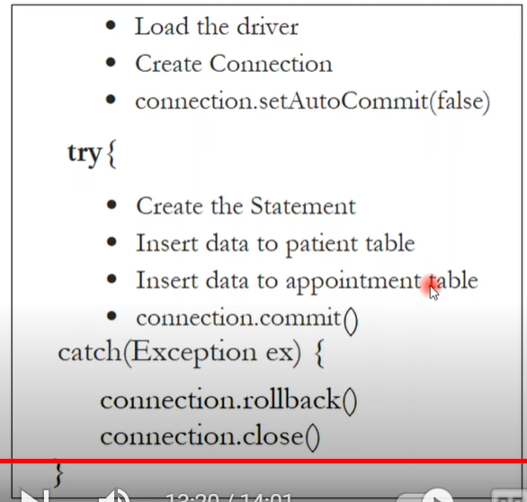

Generated Identifiers

* AUTO - Indicates that the persistence provider should pick an appropriate strategy for the particular database.
* IDENTITY - Indicates that the persistence provider must assign primary keys for the entity using a database identity column.
* SEQUENCE - Indicates that the persistence provider must assign primary keys for the entity using a database sequence.
* TABLE - Indicates that the persistence provider must assign primary keys for the entity using an underlying database table to ensure uniqueness.

### GenerationType.AUTO

The persistence provider decides on how it interprets the AUTO generation type. The java type of the identifier attribute provides an indication of how the provider will generate the identifier value.

If the identifier type is numerical (Long, Integer), then Hibernate is going to use the IdGeneratorStrategyInterpreter to resolve the identifier generator strategy.

@Entity

public class City {

@Id

@GeneratedValue or @GenaratedValue.AUTO

private Long id;

}

Hibernate by default will keep name of sequence as hibernate_sequence

Hibernate: create sequence hibernate_sequence start with 1 increment by 1

Hibernate: call next value for hibernate_sequence

### GenerationType.IDENTITY

The generation type GenerationType.IDENTITY indicates that the persistence provider must assign primary keys for the entity using a database identity column.

@Entity

public class Address {

@Id

@GeneratedValue(strategy = GenerationType.IDENTITY)

private Long id;

}

Auto-increment allows a unique number to be generated automatically when a new record is inserted into a table. By default, the starting value for AUTO_INCREMENT is 1, and it will increment by 1 for each new record.

CREATE TABLE address (

id BIGINT PRIMARY KEY AUTO_INCREMENT,

...

);

### GenerationType.SEQUENCE

The generation type GenerationType.SEQUENCE indicates that the persistence provider must assign primary keys for the entity using a database sequence.

@Id

@GeneratedValue(strategy = GenerationType.SEQUENCE)

private Long id;

The annotation type SequenceGenerator defines a primary key generator that may be referenced by name when a generator element is specified for the GeneratedValue annotation. The following attributes may be used:

* name - A unique generator name that can be referenced by one or more classes to be the generator for primary key values.
* sequenceName - The name of the database sequence object from which to obtain primary key values.
* initialValue - The value from which the sequence object is to start generating.
* allocationSize - The amount to increment by when allocating sequence numbers from the sequence.

@Entity

public class Store {

@Id

@GeneratedValue(strategy = GenerationType.SEQUENCE, generator="store-sequence-generator")

@SequenceGenerator(name = "store-sequence-generator", sequenceName = "user_sequence", initialValue = 5 , allocationSize=1)

private Long id;

}

Hibernate: create sequence user_sequence start with 5 increment by 1

### GenerationType.TABLE

The generation type GenerationType.TABLE Indicates that the persistence provider must assign primary keys for the entity using an underlying database table to ensure uniqueness. This is not recommended way to use

One to One Mapping

One to one represents that a single entity is associated with a single instance of the other entity

The @JoinColumn annotation combined with a @OneToOne mapping indicates that a given column in the CourseMaterial entity refers to a primary key in the reference entity:

@Entity

**public** **class** **CourseMaterial** {

@OneToOne(cascadeType=CascadeType.ALL)

@JoinColumn(name = "course_id",referencedColumnName= "courseId")

**Private** Course course; }

The above code example will create a foreign key linking the CourseMaterial entity with the primary key from the Course entity. The name of the foreign key column in the CourseMaterial entity is specified by name property.

**Cascading**

Cascading means to tells what type of permission should be given from parent to child entities. If you see above CourseMaterial entity we are saving record based on below ode now course object is not persisted so we need to persist course object and also course material. So this is permission.

Public void saveCourseMaterial(){

Course course=Course.builder.title(“java”).credit(6).build();

CourseMaterial courseMaterial=CourseMaterial.builder.url(“java.com”).course().build(); }

Different Cascade Types

|  |  |
| --- | --- |
| **Cascade Operations** | **Description** |
| PERSIST | In this cascade operation, if the parent entity is persisted then all its related entity will also be persisted. |
| MERGE | In this cascade operation, if the parent entity is merged then all its related entity will also be merged. Means for existing objects, to merge the existing data in the table with the data in my object. (sync to database) i.e, It first executes select statement to retrieve a manged entity from db, If persistence context already contained a managed instance its uses existing entity instead. It then updates that and returns |
| DETACH | In this cascade operation, if the parent entity is detached then all its related entity will also be detached. |
| REFRESH | In this cascade operation, if the parent entity is refreshed then all its related entity will also be refreshed. Means is to refresh the data in the object. Perhaps there was a change on the database which needs to be synced. (sync from database) |
| REMOVE | In this cascade operation, if the parent entity is removed then all its related entity will also be removed. |
| ALL | In this case, all the above cascade operations can be applied to the entities related to parent entity.  Ex: If we save an employee, then all associated accounts will also be saved into the database. If you delete an Employee then all accounts associated with that Employee also be deleted. But what if we only want the cascading on save operations but not on delete operations? Then we need to use PERSIST which will only allow persist not delete |

FETCH TYPES

FETCHTYPE.EAGER,FETCHTYPE.LAZY

How we want to fetch the data. Like once you have relationship between to tables then once you call to retrieve data for parent class then do you also need to fetch child class data or is not needed based on requirement.

So for Eager loading it will retrieve both parent and child data.

For Lazy loading it will only retrieve parent data and if you specify that you also need child data then it will also fetch child data by setting optional=false.

By default if you don’t specify any type hibernate will take lazy loading.

Some times Lazy loading can cause NullpointerException, but In Eager Type say if you have 10 different relationships the you don’t need all those child data to retrieve from database as consumes memory space(as it takes from db & keeps in java memory) and also expensive in terms of time. So mostly Lazy will be choosed

Eager loading

Advanatges

No delayed initialization-related performance impacts

Disadvantages:

* Long initial loading time
* Loading too much unnecessary data might impact performance

Lazy Loading

Advantages:

* Much smaller initial load time than in the other approach
* Less memory consumption than in the other approach

Disadvantages:

* Delayed initialization might impact performance during unwanted moments.
* In some cases we need to handle lazily initialized objects with special care, or we might end up with an exception.

Bidirectional Association

Bidirectional association allows us to fetch details of dependent object from both side. In such case, we have the reference of two classes in each other.

* Let's take an example of Employee and Address, if Employee class has-a reference of Address and Address has a reference of Employee. Additionally, you have applied one-to-one or one-to-many relationship for the classes in mapping file as well, it is known as bidirectional association.

@OnetoOneMapping(mappedBy=”address”) //this way we can have a reference as we already mentions join column in other class

If you don’t have this reference in the class then it will be unidirectional i.e, only from the main mapping defined class. From that repository only you can access child elements

Ex: Here in OnetoOneMapping directly foreign key column will be created by specifying @OnetoOneMapping



OnetoManyMapping

Student will have list have laptops. but in OnetoManyMapping it will create new table which consists of primary key and foreign key. So how to not do that?



So we are telling Student class that it is mapped By so extra table will not create and it will map with extra column. Same with ManytoMany as well we need to specify mapping bidirectionally both sides and mention mappedBy. JoinColumn will be helpful in Unidirectional case and also for bidirectional case that for parent class this particular column is joined



JPA Repository extends PagingAndSortingRepository this repo extends crud repository

PagingAndSorting:

1. Create or obtain a *PageRequest* object, which is an implementation of the *Pageable* interface
2. Pass the *PageRequest* object as an argument to the repository method we intend to use

We can create a *PageRequest* object by passing in the requested page number and the page size.

Lets say we have 6 records then when we execute by this firstPageWithTwoElements there will be 3 pages as we mentioned 2 as page size and will retrieve first page as we mentioned 0 as page number. In second case it will have 2 pages and you are retrieving second page with one record as you mentioned 1

Here**the page count starts at zero:**

This is 1st page which has 2 records

**Pageable** firstPageWithTwoElements = PageRequest.of(0, 2);

//This is 2nd page which has 5 records

**Pageable** secondPageWithFiveElements = PageRequest.of(1, 5);

Page<Product> allProducts = productRepository.findAll(firstPageWithTwoElements);

OR

List<Product> allProducts = productRepository.findAll(firstPageWithTwoElements).getContent();

long totalElements=productRepository. findAll(firstPageWithTwoElements).getTotalElements();

Long totalpages=productRepository.

findAll(firstPageWithTwoElements).getTotalElements();

**we can also sort**

Pageable sortedByName =

PageRequest.of(0, 3, Sort.by("name"));

Pageable sortedByPriceDesc =

PageRequest.of(0, 3, Sort.by("price").descending());

Pageable sortedByPriceDescNameAsc =

PageRequest.of(0, 5, Sort.by("price").descending().and(Sort.by("name")));

Page<Product> allProducts = productRepository.findAll(firstPageWithTwoElements);